**Little mp3**

# 1. Learning goals

In this lesson, we will learn to use the micro:bit on board buzzer and button. When we press button on Micro:bit, buzzer will play different music.

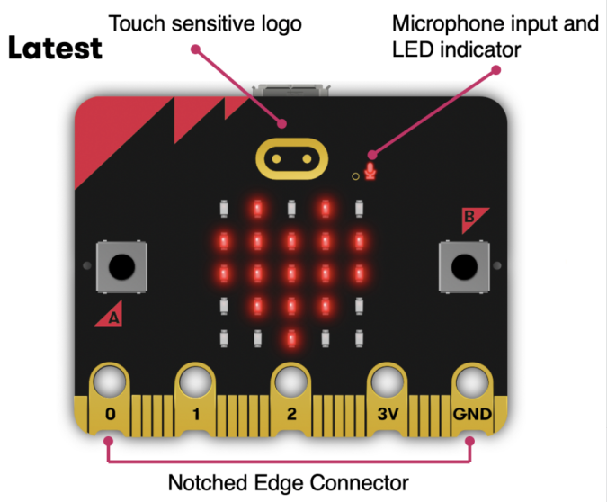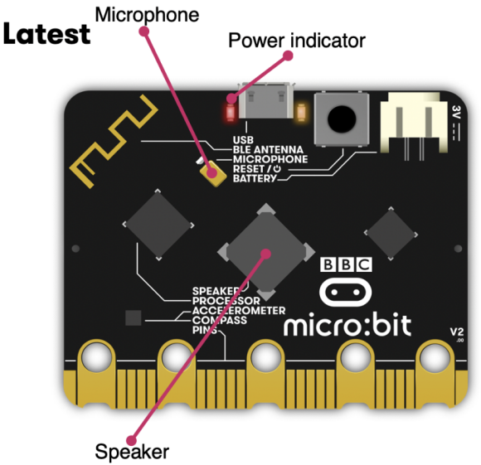

1. **Mode 1 online programming:**

First, we need to connect the micro:bit to the computer by USB cable. The computer will pop up a USB flash drive and click on the URL http://microbit.org/ in the USB flash drive to enter the programming interface to start program.

**Mode 2 offline programming:**

We need to open the offline programming software. After the installation is complete, enter the programming interface, click【New Project】, you can start program.

**3.Looking for blocks**

The following is the location of the building blocks required for this programming.

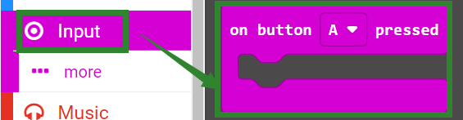

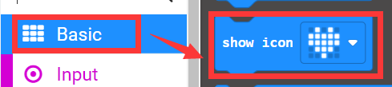

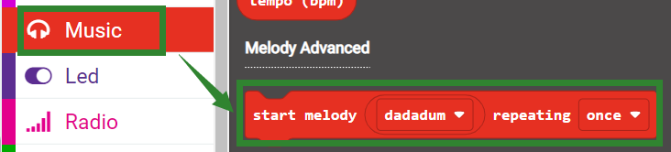

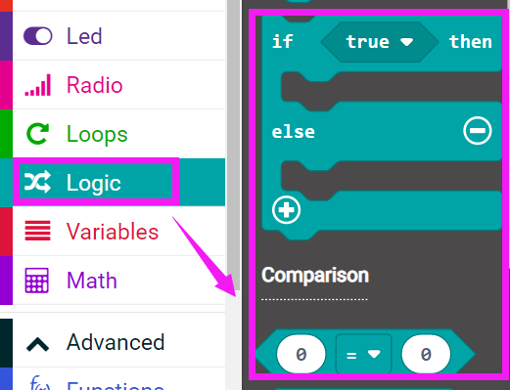

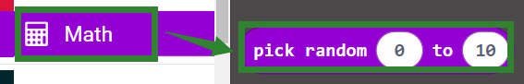

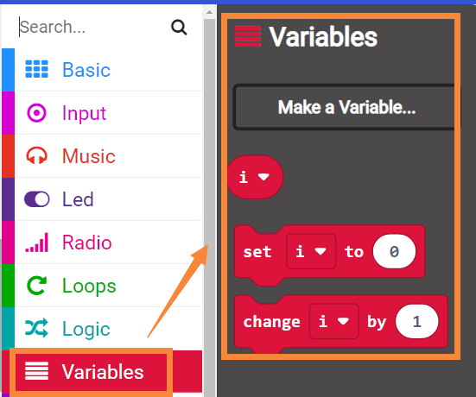

**4.Combine block**

The summary program is shown below.

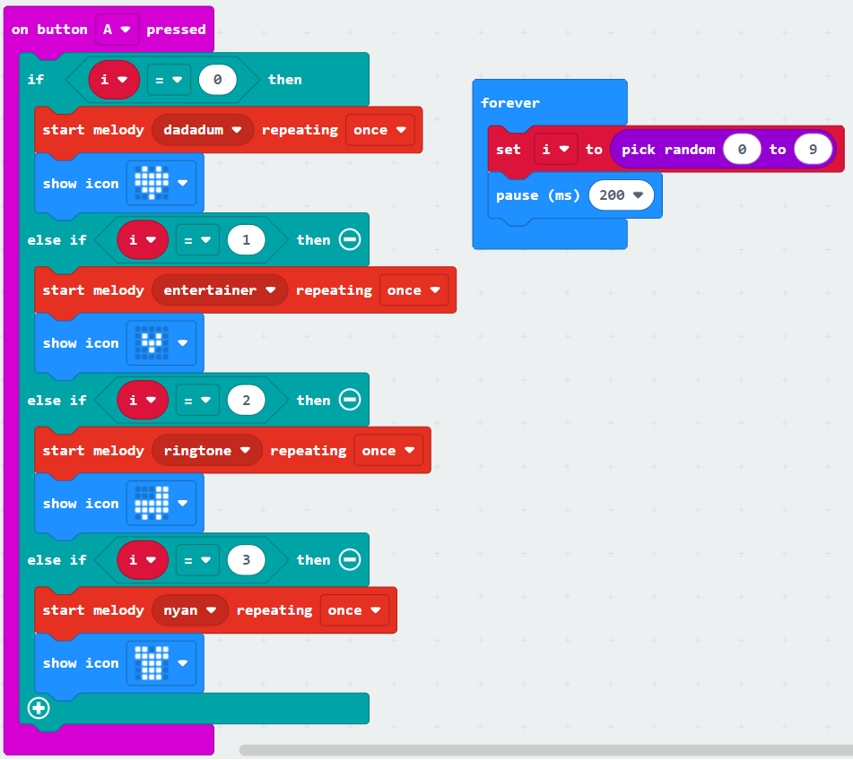

**5.Experimental phenomena**

After connecting the computer to the micro:bit board via the micro USB data cable. Click download or save on the programming interface, and the program can be successfully downloaded to the Micro:bit board.

When we press button-A on Micro:bit board, buzzer will start play music. After playing, when we press the A button again, it will switch to the next song.